 | 12.1.64 Editors - Geometry Nodes Editor - Header - Add Menu - Geometry Nodegroups - Hair - Read
Table of content
Detailed table of content 1
Add menu - Hair - Read 2
Curve Info 3
Curve Root 3
Curve Segment 4
Curve Tip 4
Hair Attachment Info 4

Detailed table of content
Table of content
Detailed table of content 1
Add menu - Hair - Read 2
Curve Info 3
Output 3
Curve Index 3
Curve ID 3
Length 3
Direction 3
Random 3
Surface UV 3
Curve Root 3
Output 3
Root Selection 3
Root Position 3
Root Direction 3
Root Index 3
Curve Segment 4
Output 4
Segment Length 4
Segment Direction 4
Neighbor Index 4
Curve Tip 4
Output 4
Tip Selection 4
Tip Position 4
Tip Direction 4
Tip Index 4
Hair Attachment Info 4
Input 4
Surface Geometry 4
Surface UV Map 4
Output 5
Attachment UV 5
Attachment is Valid 5
Surface Normal 5

Add menu - Hair - Read

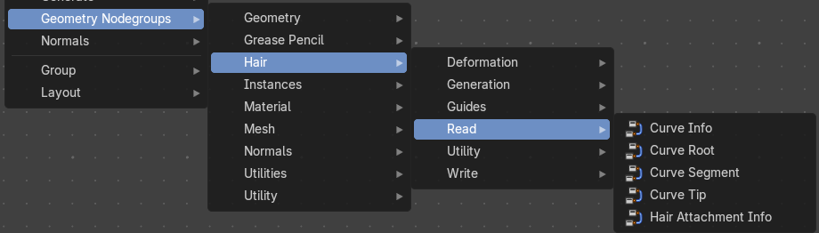
The nodes in this submenu are node groups. They use the regular single nodes under the hood.
It is virtually impossible to document these nodes in detail. So we will just list them.
When you double click the header, then you will enter the first level of the group. When you then press tab, or click again at the header, then you will reach the single nodes.




To leave the group you can use the breadcrumb up left in the header. These breadcrumbs are clickable. Or the Parent Node Tree button up right in the header.

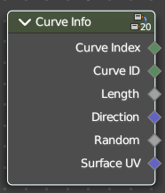
Curve Info
Reads information about each curve.

Output

Curve Index
Index of each curve.

Curve ID
ID of each curve.

Length
Length of each curve.

Direction
Direction of each curve.

Random
Random Vector of each curve.

Surface UV
Attachment surface UV coordinate of each curve.

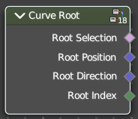
Curve Root
Reads information about the root point of each curve.

Output

Root Selection
Boolean selection of curve root points.

Root Position
The position of a root point of a curve.

Root Direction
Direction of the root segment of a curve.

Root Index
Index of the root point of a curve.

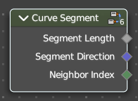
Curve Segment
Reads the information of the curve segment before the current point.

Output

Segment Length
Length of the segment

Segment Direction
Direction of the segment

Neighbor Index
Index of the neighbouring point on segment.

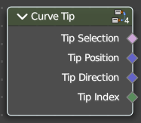
Curve Tip
Reads information about the tip point of each curve.

Output

Tip Selection
Boolean selection of the tip points.

Tip Position
Position of the tip point of a curve.

Tip Direction
Direction of the segment of the tip point of a curve.

Tip Index
Index of the tip point of a curve.

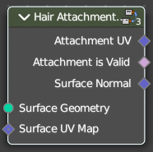
Hair Attachment Info
Reads attatchment information regarding a surface mesh.

Input

Surface Geometry
Surface geometry of the curve attachment.

Surface UV Map
Surface UV map used for attachment.

Output

Attachment UV
Surface attachment UV coordinate stored on each curve.

Attachment is Valid
Is the attached UV coordinate valid?

Surface Normal
The normal direction of the surface mesh at the attachment point.

